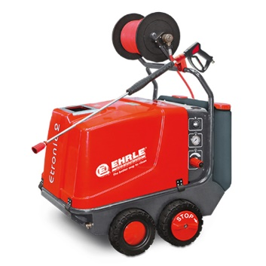

EHRLE HD 823 Hot, cold and steam cleaner
Mounted on 4 equal sized wheels for easy movement. Fitted with a heavy-duty 4 pole pump and motor and supplied with a 10 metre high pressure hose, trigger pistol and 900mm lance.
Power requirements:
Single phase 230 volt, Motor power 3.6kW. Plugs into normal 3 pin electrical socket.
Power output:
Pump pressure 110Bar (1600psi), Water flow 720 litres/hour.
Warranty:
12 months parts and labour. Heating coil has 24 months.
Features:
Low fuel and low water switch off preventing damage to unit.
24v safety circuit:
All components controlled at 24v so no risk of electrocution.
Leakage recognition: Pump shuts down if a leak is detected so preventing wear.
Total switch off after 20 minutes of no use unit switches off completely.
Magic eye monitors boiler & switches off diesel if burner malfunctions.
Large fuel and detergent tanks:
Long run time between fill ups.
Dimensions: 1150 x 750 x 800 mm Weight – 135 kg
Options available:
Hose Reel: See illustration above. Holds up to 20 metres of high-pressure hose.
Extra-long lance: For reaching to the top of trucks or buildings
Extension hose: 10, 15 & 20 metre high pressure extension hoses are available.
Drain hose & nozzle: For clearing blocked drains Turbo Lance: For removing thick mud and dirt undercarriage Lance Has 90 degree bend for cleaning chassis.
Detergent/degreaser for engines and bodywork. Supplied in 25lt drums.

JFixServices, 1 Bouvervie Close, Wheddon Cross, Minehead, Somerset,TA247EP
JFixServices@gmail.com TEL: 07989332046

